# C4- S5 - PRACTICE

# Car Inventory Management System

There are many different inventory management techniques that can be used on trucks or materials for either using or selling in a company. For example, Inventory management is used to keep track of the working progress of a variety of data in order to keep a detailed record of goods of seller’s information, product detail , dates of selling , supplier details , cost , quantity of goods.It is not to keep track only of customers ordering products but also to have a good plan for staff to buy products for your store as well to avoid no more products at your store. As a manager you can keep track of all ordering from customers and staff as well.

Think of a database schema of Car Inventory Management System to

manage the sales and production team as inventory management features sample.

**Q1** How many entities should be included in the inventory management system in general? What are they?

**Q2** Identify needed attribute in each entities

**Q3** Design the ERD Physical Model of the Inventory Management System database

**Q4** Implement this database in MySQL

* creating database named Sales

CREATE DATABASE SALES;

* create store table

CREATE TABLE sales.stores (

store_id INT AUTO_INCREMENT PRIMARY KEY,

store_name VARCHAR (255) NOT NULL,

phone VARCHAR (25),

email VARCHAR (255),

location VARCHAR (255));

* create staff tabel

CREATE TABLE sales.staffs (

staff_id INT AUTO_INCREMENT PRIMARY KEY,

first_name VARCHAR (50) NOT NULL,

last_name VARCHAR (50) NOT NULL,

email VARCHAR (255) NOT NULL UNIQUE,

phone VARCHAR (25),

store_id INT NOT NULL,

FOREIGN KEY (store_id)

REFERENCES sales.stores (store_id)

ON DELETE CASCADE ON UPDATE CASCADE,

FOREIGN KEY (manager_id)

REFERENCES sales.staffs (staff_id)

ON DELETE NO ACTION ON UPDATE NO ACTION

);

* create categories table

CREATE TABLE categories (

category_id INT AUTO_INCREMENT PRIMARY KEY,

category_name VARCHAR (255) NOT NULL

);

* create brand table

CREATE TABLE brands (

brand_id INT AUTO_INCREMENT PRIMARY KEY,

brand_name VARCHAR (255) NOT NULL

);

* create products table

CREATE TABLE products (

product_id INT AUTO_INCREMENT PRIMARY KEY,

product_name VARCHAR (255) NOT NULL,

brand_id INT NOT NULL,

category_id INT NOT NULL,

model_year SMALLINT NOT NULL,

price float not null ,

FOREIGN KEY (category_id)

REFERENCES production.categories (category_id)

ON DELETE CASCADE ON UPDATE CASCADE,

FOREIGN KEY (brand_id)

REFERENCES production.brands (brand_id)

ON DELETE CASCADE ON UPDATE CASCADE

);

* create customers table

CREATE TABLE customers (

customer_id INT AUTO_INCREMENT PRIMARY KEY,

first_name VARCHAR (255) NOT NULL,

last_name VARCHAR (255) NOT NULL,

phone VARCHAR (25),

email VARCHAR (255) NOT NULL,

location VARCHAR (255)

);

* create orders table

CREATE TABLE orders (

order_id INT AUTO_INCREMENT PRIMARY KEY,

customer_id INT,

order_date DATE NOT NULL,

staff_id INT NOT NULL,

FOREIGN KEY (customer_id)

REFERENCES customers (customer_id)

ON DELETE CASCADE ON UPDATE CASCADE,

FOREIGN KEY (staff_id)

REFERENCES staffs (staff_id)

);

* create orderdetails table

CREATE TABLE orderdetails(

orderdetail_id int AUTO_INCREMENT PRIMARY KEY,

order_id INT,

product_id INT NOT NULL,

quantity INT NOT NULL,

FOREIGN KEY (order_id)

REFERENCES orders (order_id)

ON DELETE CASCADE ON UPDATE CASCADE,

FOREIGN KEY (product_id)

REFERENCES production.products (product_id)

ON DELETE CASCADE ON UPDATE CASCADE

);

* create stock table

CREATE TABLE stocks (

store_id INT,

product_id INT,

quantity INT,

PRIMARY KEY (store_id, product_id),

FOREIGN KEY (store_id)

REFERENCES stores (store_id)

ON DELETE CASCADE ON UPDATE CASCADE,

FOREIGN KEY (product_id)

REFERENCES products (product_id)

ON DELETE CASCADE ON UPDATE CASCADE

);

**Q3** Insert some data in each table as below required:

* store 1 record

[INSERT](http://localhost:8080/phpmyadmin/url.php?url=https://dev.mysql.com/doc/refman/8.0/en/insert.html) INTO stores (store_name) [VALUES](http://localhost:8080/phpmyadmin/url.php?url=https://dev.mysql.com/doc/refman/8.0/en/miscellaneous-functions.html#function_values) ('KHMERAUTO');

* customers 3 records

[INSERT](http://localhost:8080/phpmyadmin/url.php?url=https://dev.mysql.com/doc/refman/8.0/en/insert.html) INTO customers (first_name,last_name,email,phone,location) [VALUES](http://localhost:8080/phpmyadmin/url.php?url=https://dev.mysql.com/doc/refman/8.0/en/miscellaneous-functions.html#function_values)('Jonh', 'Smit','jonhsmit@gmail.com',898999899, 'France' ), ('Lyly', 'Long','lylylong@gmail.com',02398989, 'Cambodia' ),('Veacha', 'Smos','veacharsmos@gmail.com',077778987, 'Kampong Thom' );

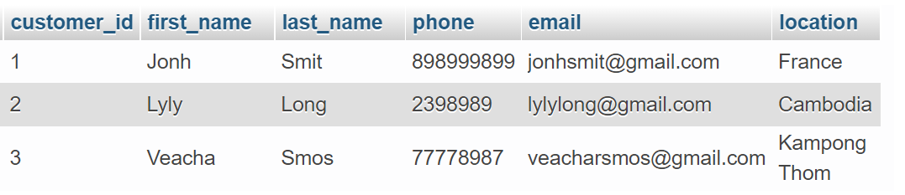

* staffs 3 records

[INSERT](http://localhost:8080/phpmyadmin/url.php?url=https://dev.mysql.com/doc/refman/8.0/en/insert.html) INTO staffs (first_name, last_name, phone, email, store_id ) [VALUES](http://localhost:8080/phpmyadmin/url.php?url=https://dev.mysql.com/doc/refman/8.0/en/miscellaneous-functions.html#function_values) ('Kanha','Meng', 09998787, 'kanhameng@gmail.com', 1),('linda','Veng', 90989898,'lindaveng@gmail.com', 1), ('Phally','Sok', 01234343,'phallysok@gmail.com', 1);

* category 3 records

[INSERT](http://localhost:8080/phpmyadmin/url.php?url=https://dev.mysql.com/doc/refman/8.0/en/insert.html) INTO categories (category_name) [VALUES](http://localhost:8080/phpmyadmin/url.php?url=https://dev.mysql.com/doc/refman/8.0/en/miscellaneous-functions.html#function_values) ('Sport Car'),('taxi'),('Dumtuck ');

* products 10 records

[INSERT](http://localhost:8080/phpmyadmin/url.php?url=https://dev.mysql.com/doc/refman/8.0/en/insert.html) INTO products (product_name,list_price, model_year,category_id,brand_id) [VALUES](http://localhost:8080/phpmyadmin/url.php?url=https://dev.mysql.com/doc/refman/8.0/en/miscellaneous-functions.html#function_values) ('GR Supra', 45000, 2021,1,1) ,('Dyna', 9000, 1990,2,1),('Camry', 2000, 2017,1,1), ('Dyna', 7000, 1990,2,1), ('Camry', 25000, 2018,1,1), ('Honda Civic Type R', 45000, 2021,1,2),('Ford F750', 20000, 2000,3,3),('ORD TOURNEO',50000, 2021,2,3);

* orders 10 records

[INSERT](http://localhost:8080/phpmyadmin/url.php?url=https://dev.mysql.com/doc/refman/8.0/en/insert.html) INTO orders (order_date, customer_id,staff_id) [VALUES](http://localhost:8080/phpmyadmin/url.php?url=https://dev.mysql.com/doc/refman/8.0/en/miscellaneous-functions.html#function_values) ('2021-08-10',1,1), ('2021-07-20',2,2), ('2020-08-10',3,2), ('2020-08-01',1,3), ('2021-05-10',2,3), ('2020-08-10',2,2), ('2020-10-10',3,2), ('2021-08-23',1,2), ('2021-08-10',1,1), ('2021-07-20',2,2), ('2020-08-10',3,2), ('2020-03-01',1,3), ('2021-02-10',2,3), ('2020-01-10',2,2);

* orderdetails 10 records

INSERT INTO `orderdetails` (order_id,product_id, quantity) VALUES

( 6, 4, '7000.00'),

( 6, 4, '7000.00'),

( 8, 2, '50000.00'),

( 8, 2, '50000.00'),

( 4, 5, '25000.00'),

( 4, 5, '25000.00'),

( 2, 2, '9000.00'),

( 2, 2, '9000.00'),

( 1, 2, '9000.00'),

( 4, 2, '9000.00');

* brand 2 records

[INSERT](http://localhost:8080/phpmyadmin/url.php?url=https://dev.mysql.com/doc/refman/8.0/en/insert.html) INTO brands (brand_name) [VALUES](http://localhost:8080/phpmyadmin/url.php?url=https://dev.mysql.com/doc/refman/8.0/en/miscellaneous-functions.html#function_values) ('Toyota'), ('Honda'),('Ford');

**Q4** Write a query to display all products that sold the most.

SELECT products.product_name as 'Product Name' ,count(products.product_name) as 'Numers of order' FROM orderdetails

INNER JOIN products on orderdetails.product_id = products.product_id

GROUP BY products.product_name ;

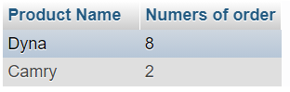

**Q5** Display for each customer , how much the customer has spend

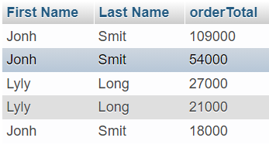

SELECT

customers.first_name as 'First Name', customers.last_name as 'Last Name',

SUM(orderdetails.quantity * products.price) orderTotal

FROM

orderdetails

INNER join orders on orderdetails.order_id = orders.order_id

INNER join customers on orders.customer_id = customers.customer_id

INNER JOIN products on orderdetails.product_id = products.product_id

GROUP BY

orders.order_id

ORDER BY

orderTotal DESC;

**Q6** displays the number of items in each category.

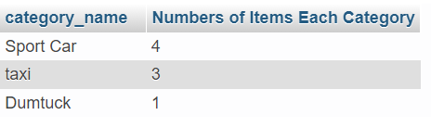

SELECT

categories.category_name,

COUNT(*) as 'Numbers of Items Each Category'

FROM

products

INNER JOIN categories on products.category_id = categories.category_id

GROUP BY

categories.category_id;

**Q7** displays the names of customers who do not buy any products.

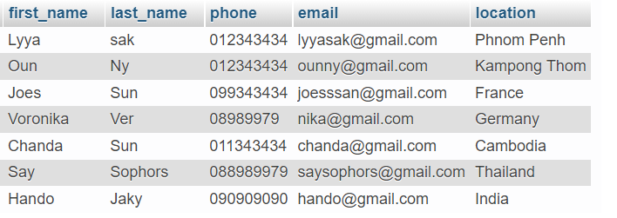

SELECT * FROM orders RIGHT JOIN customers on orders.customer_id = customers.customer_id WHERE orders.order_id is null;

**Q8** display products that are ordered without duplicate

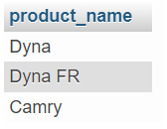

SELECT DISTINCT products.product_name FROM orderdetails

INNER join orders on orderdetails.order_id = orders.order_id

INNER join customers on orders.customer_id = customers.customer_id

INNER JOIN products on products.product_id = orderdetails.product_id

;

**Q9**  Find the products that in the stock more than 10.

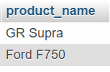

select * from products INNER join stocks on stocks.product_id = products.product_id where stocks.quantity>10;